Nama : Reihan Al Sya’Ban

NIM : 2109106051

Kelas : A2 2021

**Struktur Data**

**POSTTEST 4**

#include <iostream>

#include <string>

#include <conio.h>

#include <windows.h>

using namespace std;

struct tim_liga{

string nama_tim;

string kota_asal;

string nama_stadion;

string suporter;

int jumlah_pemain;

};

tim_liga tl;

struct Node{

tim_liga data;

Node *next = NULL;

};

bool isEmpty(Node *head){

if (head == NULL){

return true;

}

return false;

}

int length(Node *head){

int jumlah = 0;

while (head != NULL){

jumlah++;

head = head->next;

}

return jumlah;

}

Node *newNode(){

Node *nodeBaru = new Node;

cout<<"\n=============== MASUKKAN DATA ================"<<endl;

cout<<"Nama TIM : ";

cin>>nodeBaru->data.nama_tim;

cout<<"Kota Asal : ";

cin>>nodeBaru->data.kota_asal;

cout<<"Nama Stadion : ";

cin>>nodeBaru->data.nama_stadion;

cout<<"Nama Suporter : ";

cin>>nodeBaru->data.suporter;

cout<<"Jumlah Pemain : ";

cin>>nodeBaru->data.jumlah_pemain;

system("CLS");

return nodeBaru;

}

void addFirst(Node **head){

Node *nodeBaru = newNode();

nodeBaru->next = *head;

*head = nodeBaru;

}

void addLast(Node **head){

Node *nodeBaru = newNode();

if (isEmpty(*head)){

*head = nodeBaru;

}

else{

Node *temp = *head;

while (temp->next != NULL){

temp = temp->next;

}

temp->next = nodeBaru;

}

}

void addMiddle(Node **head) {

if (isEmpty(*head)) {

cout << "\n================= DATA KOSONG =================" << endl;

getch();

system("CLS");

return;

}

Node *nodeBaru = *head;

int i = 1;

while (nodeBaru != NULL) {

cout <<"\n=============== Data Ke-"<<i<<" ================"<<endl

<<"Nama TIM : "<<nodeBaru->data.nama_tim<<endl

<<"Kota Asal : "<<nodeBaru->data.kota_asal<<endl

<<"Nama Stadion : "<<nodeBaru->data.nama_stadion<<endl

<<"Nama Suporter : "<<nodeBaru->data.suporter<<endl

<<"Jumlah Pemain : "<<nodeBaru->data.jumlah_pemain<<endl;

i += 1;

nodeBaru = nodeBaru->next;

}

int index;

cout << "\n- Masukkan Data Sebelum Node Ke-";

cin >> index;

if (index > 0 && index <= length(*head)){

Node *nodeBaru = newNode();

int nomor = 1;

Node *temp = (*head);

while(nomor < index-1){

temp = temp->next;

nomor++;

}

nodeBaru->next = temp->next;

temp->next = nodeBaru;

}

else{

cout << "\n=============== DATA TIDAK TERSEDIA ===============" << endl;

}

}

void addMenu(Node*& HEAD){

int pilih = 1;

cout << "\n================= TAMBAH MENU =================" << endl

<< "\n1. Add First" << endl

<< "2. Add Middle" << endl

<< "3. Add Last" << endl

<< "Pilih : ";

cin>>pilih;

system("CLS");

if(pilih == 1){

addFirst(&HEAD);

}

else if(pilih == 2){

addMiddle(&HEAD);

}

else{

addLast(&HEAD);

}

}

void deleteFirst(Node **head){

if (isEmpty(*head)){

cout << "\nLinked List Kosong" << endl;

return;

}

*head = (*head)->next;

cout << "\nDelete Node Berhasil" << endl;

}

void deleteLast(Node **head){

if (isEmpty(*head)){

cout << "\nLinked List Kosong" << endl;

return;

}

if ((*head)->next == NULL){

*head = NULL;

cout << "\nDelete Node Berhasil" << endl;

return;

}

Node *temp = *head;

while (temp->next->next != NULL){

temp = temp->next;

}

Node *varDelete = temp->next;

temp->next = NULL;

delete varDelete;

cout << "\nDelete Node Berhasil" << endl;

}

void deleteMiddle(Node*& head) {

if (head == NULL)

return;

if (head->next == NULL) {

delete head;

return;

}

struct Node* copyHead = head;

int count = length(head);

int mid = count / 2;

while (mid-- > 1)

head = head->next;

head->next = head->next->next;

}

void deleteMenu(Node*& HEAD){

int pilih = 1;

cout << "\n================= DELETE MENU =================" << endl

<< "\n1. Delete First" << endl

<< "2. Delete Middle" << endl

<< "3. Delete Last" << endl;

cout<<"Pilih : ";

cin>>pilih;

system("CLS");

if(pilih == 1){

deleteFirst(&HEAD);

}

else if(pilih == 2){

deleteMiddle(HEAD);

}

else{

deleteLast(&HEAD);

}

}

void display(Node *head){

if (isEmpty(head)){

cout << "Linked List Kosong" << endl;

return;

}

cout << "\n=================== DATA TIM ==================" << endl;

Node *temp = head;

while (temp != NULL){

cout<<"\nNama TIM : "<< temp->data.nama_tim <<endl;

cout<<"Kota Asal : "<< temp->data.kota_asal <<endl;

cout<<"Nama Stadion : "<< temp->data.nama_stadion <<endl;

cout<<"Nama Suporter : "<< temp->data.suporter <<endl;

cout<<"Jumlah Pemain : "<< temp->data.jumlah_pemain <<endl;

cout << "\n===============================================" << endl;

temp = temp->next;

}

getch();

system("CLS");

cout << endl;

}

void update(Node **head){

if (isEmpty(*head)){

cout << "\nLinked List Kosong" << endl;

getch();

system("CLS");

return;

}

int pilihan = 0;

cout << "Banyak node ada : " << length(*head) << endl;

cout << "Pilih node yang ingin diupdate : ";

cin >> pilihan;

Node *temp = *head;

if (pilihan > 0 && pilihan <= length(*head)){

for (int i = 1; i < pilihan; i++){

temp = temp->next;

}

cout<<"\nNama TIM : ";

cin>>temp->data.nama_tim;

cout<<"Kota Asal : ";

cin>>temp->data.kota_asal;

cout<<"Nama Stadion : ";

cin>>temp->data.nama_stadion;

cout<<"Nama Suporter : ";

cin>>temp->data.suporter;

cout<<"Jumlah Pemain : ";

cin>>temp->data.jumlah_pemain;

getch();

system("CLS");

}

else{

cout << "\nInputan melebihi jumlah node" << endl;

getch();

system("CLS");

}

}

Node *SortedMerge(Node *a, Node *b, int attribute, int type);

void FrontBackSplit(Node *source, Node **frontRef, Node **backRef);

void MergeSort(Node **headRef, int attribute, int type)

{

Node *head = *headRef;

Node *a;

Node *b;

if ((head == NULL) || (head->next == NULL))

{

return;

}

FrontBackSplit(head, &a, &b);

MergeSort(&a, attribute, type);

MergeSort(&b, attribute, type);

*headRef = SortedMerge(a, b, attribute, type);

}

Node *SortedMerge(Node *a, Node *b, int attribute, int type)

{

Node *result = NULL;

bool isAsc = type == 1;

bool condition = false;

if (a == NULL)

return (b);

else if (b == NULL)

return (a);

if(attribute == 1) {

condition = isAsc ? a->data.nama_tim <= b->data.nama_tim : a->data.nama_tim >= b->data.nama_tim;

} else if(attribute == 2) {

condition = isAsc ? a->data.suporter <= b->data.suporter : a->data.suporter >= b->data.suporter;

} else if(attribute == 3) {

condition = isAsc ? a->data.jumlah_pemain <= b->data.jumlah_pemain : a->data.jumlah_pemain >= b->data.jumlah_pemain;

}

if (condition) {

result = a;

result->next = SortedMerge(a->next, b, attribute, type);

} else {

result = b;

result->next = SortedMerge(a, b->next, attribute, type);

}

return (result);

}

void FrontBackSplit(Node *source, Node **frontRef, Node **backRef)

{

Node *fast;

Node *slow;

slow = source;

fast = source->next;

while (fast != NULL)

{

fast = fast->next;

if (fast != NULL)

{

slow = slow->next;

fast = fast->next;

}

}

*frontRef = source;

*backRef = slow->next;

slow->next = NULL;

}

void sort(Node **head)

{

int attribute = 1;

int type = 1;

cout<< "=================== KATEGORI ==================" << endl

<< "1. Nama Tim" << endl

<< "2. Nama Suporter" << endl

<< "3. Jumlah Pemain" << endl

<< "Pilih : ";

cin >> attribute;

cout<< "==================== METODE ==================" << endl

<< "1. Ascending" << endl

<< "2. Descending" << endl

<< "Pilih : ";

cin >> type;

MergeSort(head, attribute, type);

cout << "Data Berhasil Disorting" << endl;

}

int fibonacciSearch(Node *node, string x, int n){

int F0 = 0;

int F1 = 1;

int F = F0 + F1;

while (F < n){

F0 = F1;

F1 = F;

F = F0 + F1;

}

int offset = -1;

int trv = 0;

while (F > 1){

Node *temp = node;

int i = min(offset + F0, n - 1);

while (temp->next != NULL && trv < i){

temp = temp->next;

trv++;

}

if (temp->data.nama_tim < x){

F = F1;

F1 = F0;

F0 = F - F1;

offset = i;

}

else if (temp->data.nama_tim > x){

F = F0;

F1 = F1 - F0;

F0 = F - F1;

}

else return i;

trv = 0;

}

Node *temp2 = node;

while (temp2->next != NULL && trv < offset +1){

temp2 = temp2->next;

trv++;

}

if (F1 && temp2->data.nama_tim == x) return offset + 1;

return -1;

}

void search(Node **head){

system("cls");

cout << "\n================== CARI DATA ==================" << endl;

if (isEmpty(*head)) {

cout << "\n================= DATA KOSONG =================" << endl;

return;

}

string key;

int data;

Node *temp = *head;

string searchkey;

int lengthh = length(*head);

int index = 0;

cout << "\nMasukkan Nama Tim yang dicari : ";

cin>>searchkey;

int idx = fibonacciSearch(*head, searchkey, lengthh);

int nomor = idx + 1;

if (idx >= 0) {

while (temp != NULL){

if (index == idx){

cout <<"\n=============== Data Ke-"<<nomor<<" ================"<<endl

<<"Nama TIM : "<<temp->data.nama_tim<<endl

<<"Kota Asal : "<<temp->data.kota_asal<<endl

<<"Nama Stadion : "<<temp->data.nama_stadion<<endl

<<"Nama Suporter : "<<temp->data.suporter<<endl

<<"Jumlah Pemain : "<<temp->data.jumlah_pemain<<endl;

break;

}

index++;

temp = temp->next;

}

}else{

cout << "\n================= DATA KOSONG =================" << endl;

}

getch();

system("CLS");

}

int main()

{

Node *HEAD = NULL;

int pilihan = 0;

while (pilihan != 7)

{

cout << "\n================= LINKED LIST =================" << endl;

cout << "\n1. Create" << endl;

cout << "2. Read" << endl;

cout << "3. Update" << endl;

cout << "4. Delete" << endl;

cout << "5. Sorting" << endl;

cout << "6. Searching" << endl;

cout << "7. Exit Program" << endl;

cout << "Masukan pilihan : ";

cin >> pilihan;

system("CLS");

switch (pilihan)

{

case 1:

addMenu(HEAD);

break;

case 2:

display(HEAD);

break;

case 3:

update(&HEAD);

break;

case 4:

deleteMenu(HEAD);

break;

case 5:

sort(&HEAD);

break;

case 6:

MergeSort(&HEAD, 1, 1);

search(&HEAD);

break;

case 7:

break;

default:

break;

}

}

return 0;

}

1. Data Awal

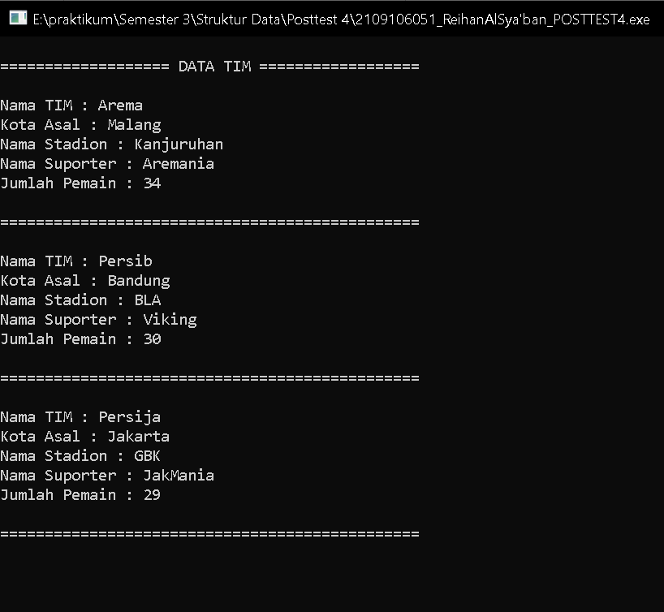

1. Searching Nama tim

